14-Night South America (South American Coast)
Holland America Line: Zaandam

March 21, 2017 – April 4, 2017 Buenos Aires, Argentina to Valparaiso/Santiago, Chile

Designed to carry fewer guests while providing more space for maximum comfort, the ms Zaandam is a prize in the mid-size ship category. Offering spacious public areas and plush accommodations, many staterooms have private verandahs. The musically themed ms Zaandam offers a unique shipboard atmosphere. Inspired by the world's great music, artifacts and memorabilia from a variety of musical genres decorate the ship. You'll find musical instruments such as Bill Clinton's saxophone and signed guitars from Queen, Iggy Pop, Eric Clapton and the Rolling Stones used as art objects throughout the ship. At the heart of the ms Zaandam, in a soaring three-story atrium: a Baroque-style Dutch pipe organ, inspired by the traditional barrel organs still found on the streets of The Netherlands. Enjoy an onboard IPod self-guided tour of the complete Zaandam art collection.

Ship Highlights:
- Rotterdam Dining Room, feautring impeccable service and an extensive wine list
- Pinnacle Grill, a reservations-only elegant dining experience
- Canaletto Restaurant, featuring authentic Italian cuisine
- Lido Restaurant, featuring cook-to-order specialties
- The Culinary Arts Center, powered by Food & Wine magazine
- Explorations Cafe, powered by The New York Times
- Greenhouse Spa and Salon
- Digital Workshop, powered by Windows
- Mondriaan Show Lounge
- Crow's Nest, featuring sweeping 270-degree views during the day and a hip, fashionable nightclub each evening
- Club Hal youth programs designed for children ages 3-12
- The Loft teen programming designed for teens ages 13-17
Ship Facts:
Ship's Registry: The Netherlands
Passenger capacity: 1,432
Crew members: 615
Gross Tonnage: 61,396 grt.
Room Types: Inside Cabin (136), Ocean View (383), Balcony/Vista Suit (168)
Length: 781 feet
Beam: 105.8 feet
Maximum speed: 23 knots
Dedicated: May 2000, by actresses Mary-Kate & Ashley Olsen

Day by Day Summary and Map
Itinerary Map
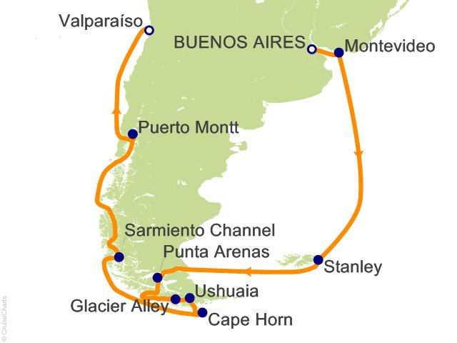

Itinerary Details

Day | Ports of Call | Arrival | Departure
Tuesday, 21 March 2017 | Buenos Aires, Argentina | — | —
Wednesday, 22 March 2017 | Buenos Aires, Argentina | — | 06:00 PM
Thursday, 23 March 2017 | Montevideo, Uruguay | 08:00 AM | 06:00 PM
Friday, 24 March 2017 | At Sea | — | —
Saturday, 25 March 2017 | At Sea | — | —
Sunday, 26 March 2017 | Stanley, Falkland Islands | 08:00 AM | 06:00 PM
Monday, 27 March 2017 | Strait of Magellan | — | —
Tuesday, 28 March 2017 | Punta Arenas, Chile | 06:00 AM | 06:00 PM
Tuesday, 28 March 2017 | Cockburn Channel, Chile | — | —
Tuesday, 28 March 2017 | Beagle Channel | — | —
Wednesday, 29 March 2017 | Glacier Alley, Chile | — | —
Wednesday, 29 March 2017 | Ushuaia, Argentina | 02:00 PM | 08:00 PM
Thursday, 30 March 2017 | Cape Horn, Chile | — | —
Friday, 31 March 2017 | Sarmiento Channel, Chile | — | —
Saturday, 01 April 2017 | Chilean Fjords, Chile | — | —
Sunday, 02 April 2017 | Puerto Montt, Chile | 08:00 AM | 05:00 PM
Monday, 03 April 2017 | At Sea | — | —
Tuesday, 04 April 2017 | Valparaíso, Chile | 06:00 AM | —

